PROJECT NAME: Insert Project name here

Describe the Environment

- The text from the DESCRIBE ENVIRONMENT goes in here

Intent and Objective

- The text from the INTENT goes in here
- The text from the OBJECTIVE goes here
Responsibilities and method

- Method.
  - The text from Method goes in here
- Responsibilities.
  - The first task goes here
    - Who
    - When
  - The second task goes here
    - Who
    - When
  - The third task goes here
    - Who
    - When
  - The fourth task goes here
    - Who
    - When
Enablers and Resources

- Enablers.
  - The text from ENABLERS goes here
- Resources.
  - The text from ENABLERS goes here

Coordination

- The text from COORDINATION goes here.
- The GANTT chart goes here.
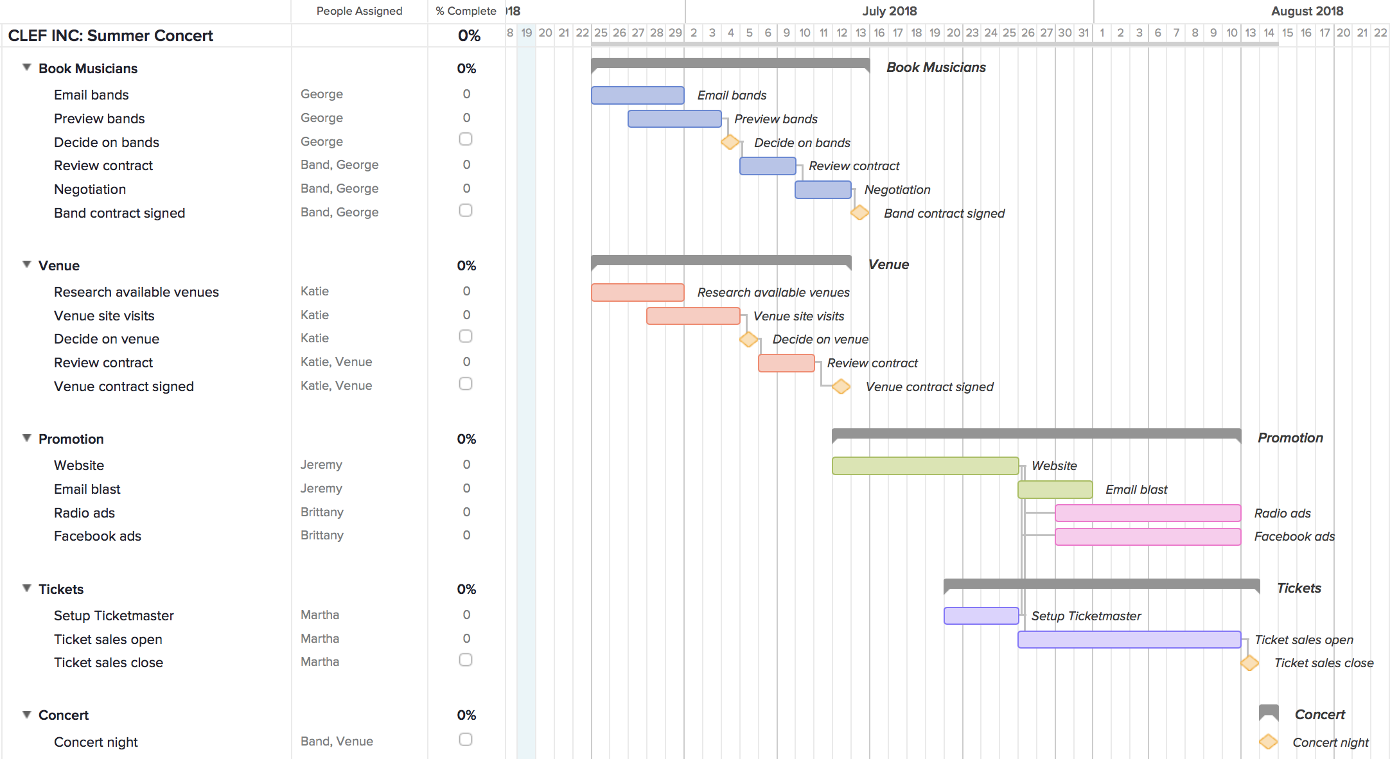

Timings

- Meetings.
  - Who
  - What
  - When
  - Where

- Milestones.
  - [INSERT DATE] - [Insert Milestone 1 text here]
  - [INSERT DATE] - [Insert Milestone 2 text here]
  - [INSERT DATE] - [Insert Milestone 3 text here]
  - [INSERT DATE] - [Insert Milestone 4 text here]
  - [INSERT DATE] - [Insert Milestone 5 text here]

- Deadlines.
  - [INSERT DATE] - [Insert Deadline 1 text here]
  - [INSERT DATE] - [Insert Deadline 2 text here]
  - [INSERT DATE] - [Insert Deadline 3 text here]
  - [INSERT DATE] - [Insert Deadline 4 text here]
  - [INSERT DATE] - [Insert Deadline 4 text here]

- Authorised by:
  - Insert name
  - Insert position
  - Insert date

